Atitit 支付pay 文档

https://m11086.88.nf/#/Recharge

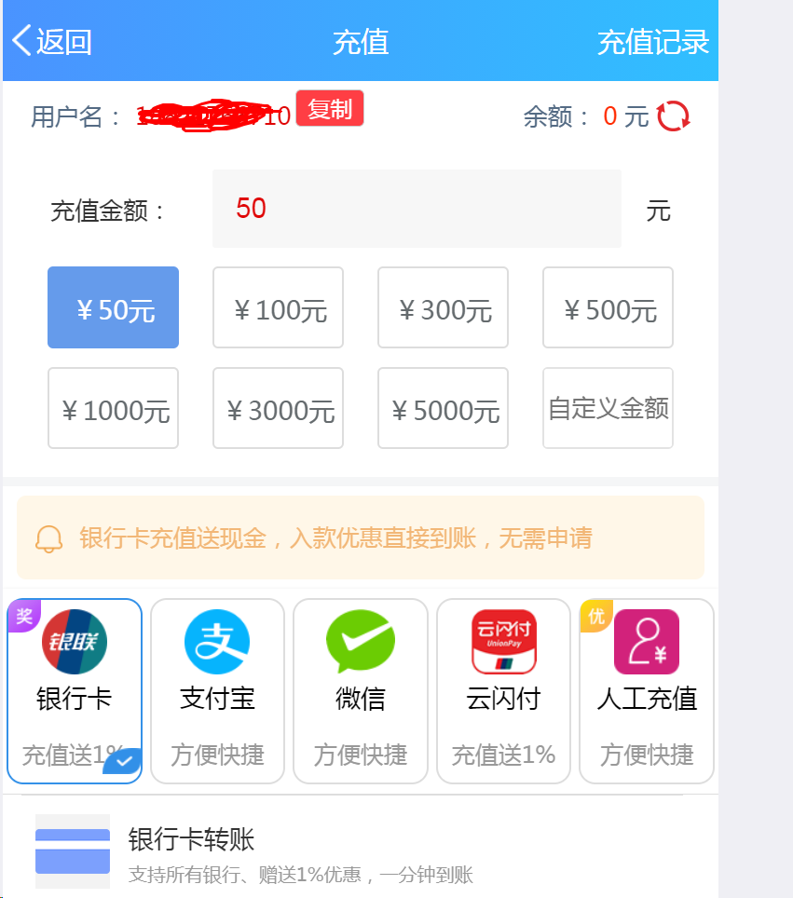

# 添加支付订单

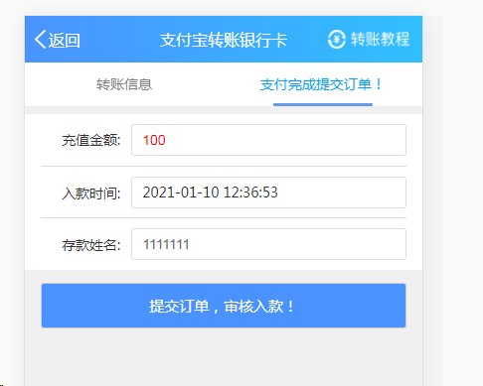

提交到 https://m11086.88.nf/apis/member/submitAliPay2Bank.json

{"result":206,"description":"您有1笔存款正在入款，请稍后再提交！"}